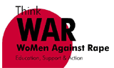

**16 DAYS OF ACTIVISM AGAINST GENDER BASED VIOLENCE 2017**

**REPORT**

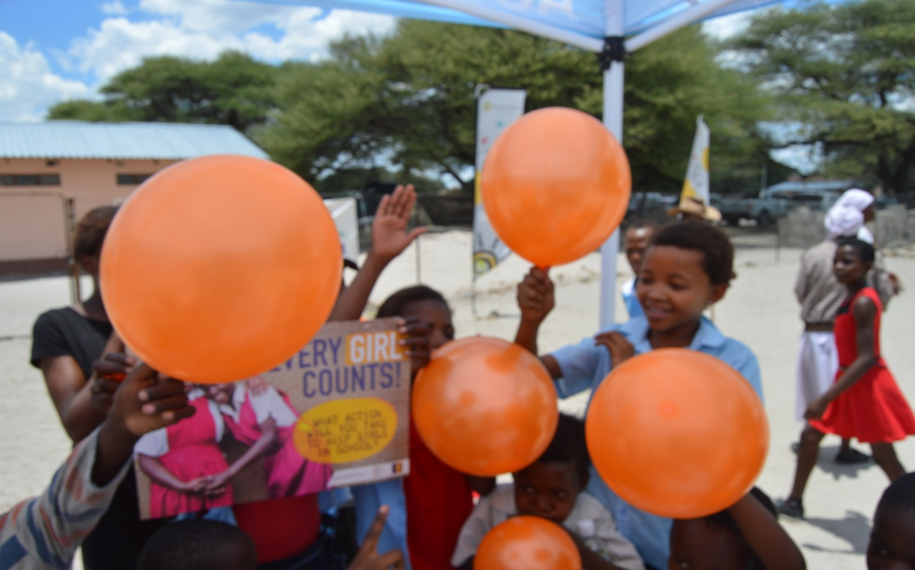

**16 DAYS OF ACTIVISM PREPARATORY MEETING**

On the 19th December 2018 Women Against Rape held a preparatory meeting at Love Botswana with other stakeholders to plan for 16days and collaborate with other stakeholders on different events they will be hosting their activities. Total attendance was 27, 5 being the WAR staff and 22 being individual representative from different stakeholders. At the end of the meeting all stakeholders have shared their ideas and dates of events. All stakeholders agreed to start up a Whatsapp which they will use to keep in touch with each other and give updates on a daily basis.

**Total Attendance**: 27 **male**: 7 **female**: 20

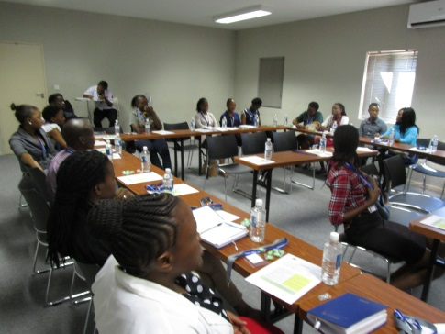 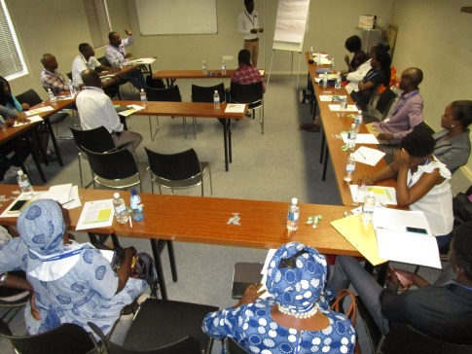

**16 DAYS OF ACTIVISM LAUNCH CAMPAIGN**

**Orange the world hash tag social media campaign**

Women against rape 16 days of activism team came up with social media campaign on addressing by using taglines *#orangetheworld* an initiative from United Nations and *#IamAgainstGBV* for the local community.

Below are the pictures portraying how the community was showing their commitment against gender based violence? Before any member was taken a photo, they were educated and enlighten on the 16 days of activism and given a choice to take a photo as a pledge to be against GBV thou other commitments has like work has not allowed them a chance to attend our meetings/campaigns. About 99 people of different gender, race, ages and cultures were reached through the hashtag social media campaign. There was only 1 audible video recorded of a women expressing about her thoughts on GBV and what she knows about the 16 days of activism campaign.

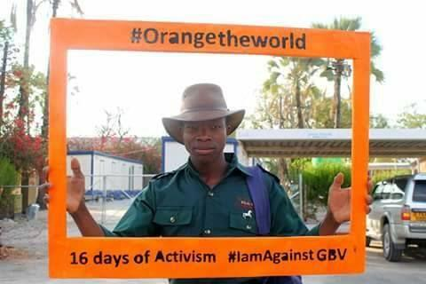 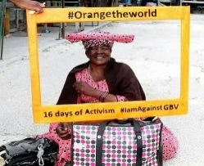 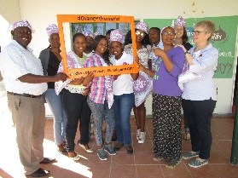

For more pictures follow the link: <https://www.facebook.com/photo.php?fbid=983809058426310&set=pcb.983812438425972&type=3>

Total number of people reached via Facebook insights; **9687** from 13/12/2017 to 1/12/2017

Unfortunately it was not easy to differentiate the people by their gender.

**WOMEN AGAINST RAPE LAUNCHES 16 DAYS OF ACTIVISM CAMPAIGN**

On the 24th November 2017, WoMen Against Rape launched 16 days of activism campaign at Sedie Junior Secondary School. The purpose of this event was to familiarize the students with year 2017 theme “**every girl count! What action will you take to keep girls in school?**” to raise awareness on preventing violence against women and children.

Different local stakeholders among them: Tebelopele Voluntary Counselling and Testing Centre (TVCT), Thuso rehabilitation center (TRC), Department of Health and others attended the event to support and showcase their services. The audience was addressed by students from different secondary schools in Maun by through giving speeches and poem reciting that brought out their knowledge and understanding of the theme and gender based violence in general.

“*Without my confidence, without my assertiveness, without my esteem how will the nation be alive? Empowered as a girl, I can stand firm and never get troubled. I say NO to what deserve it, my foundation is strong as a mountain because I am empowered as a girl.”*   Extracted from Student Poet

The place was covered with orange colors (tag line “#orangetheworld”) as a way to show that the community is against violence against women and children.

***Total number of people registered:  73 Female, 16 Male, total = 89***

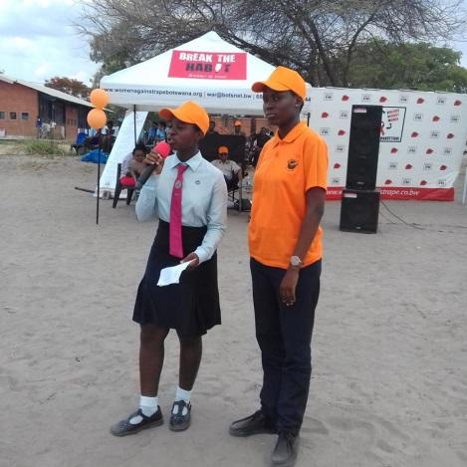 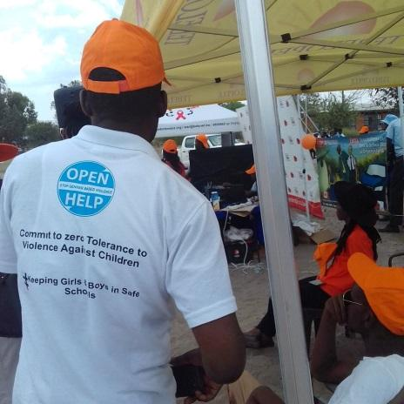 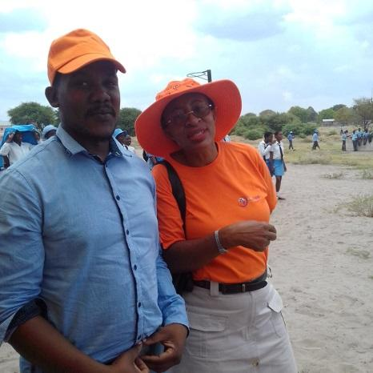

28 Nov 2017

**BORO PRISON FARM 16 DAYS OF ACTIVISM LAUNCH**

Boro Prison Farm hosted 16days of activism against GBV to its community on the 28th November 2017.Boro Prison farm residents is only man, and the employees are mostly male dominated and only a handful of female. Majority of the community residents were youth aged between 22 and 38 years old serving for different crimes. They were a very understanding and engaging community, they gave information through poem, drama and choir singing. All the messages were very informative and relevant to the 16 days as they were all addressing gender based violence against women and children and also ways to which they can help address issues or problems /misunderstandings in the future without using violence and lastly recommended different stakeholders where they can seek help to avoid taking the law in to their own hands in the future. Women Against Rape was invited to give a keynote speech. The Executive Director Peggie Ramaphane gave a speech on the history of 16 days of Activism campaign against Gender Based Violence and she quoted entertaining groups for the day to give living examples or insights of different types of GBV. And also made it clear that GBV affect everyone, it doesn’t discriminate or care whether you are man, woman, black, white, rich or poor it affects all and they shouldn’t be ashamed to speak up because silence is also violence. The keynote speaker ended by informing the attendants about services that Women Agaisnt Rape offers and reassured them that all are welcome to seek help at our office. “We don’t discriminate anyone” she concluded.

***Total number reached 231= 7 female and 224 male***

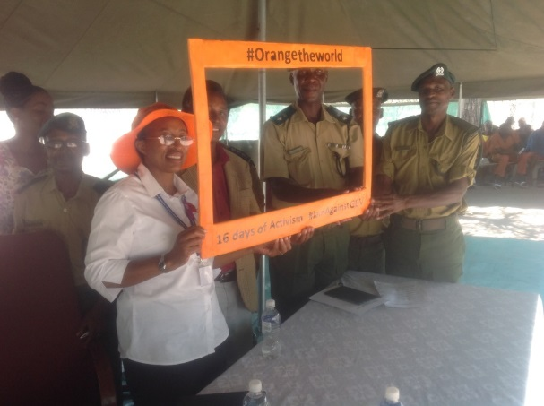 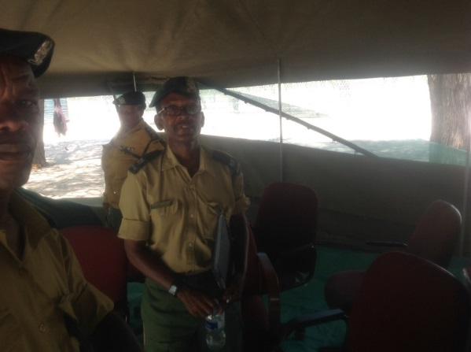

**World AIDS Day at Chanoga Village**

On the 1st December 2017, Ministry of health and District AIDS Coordination held World AIDS day commemoration in Chanoga village with the theme for the year 2017 “Right to health”. Women Against Rape with other stakeholder were to set a stall and provide their services to the public on the event. The public was addressed by Kgosi Setlhodi with opening remarks and advised people to always find someone to share their concerns or problems with. He concluded by advising people that the clinics and hospitals must be their refuge when it comes to their health and family planning. On the agenda was also Prophet T.P Elias who said, ’It is very important for all to get tested and know their HIV status. ’All religions must stand up and help in the fight against HIV/AIDS’

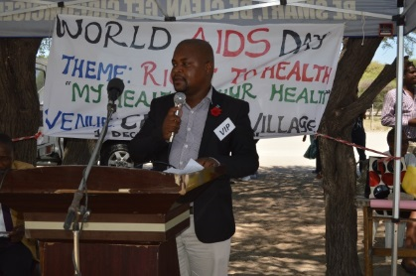 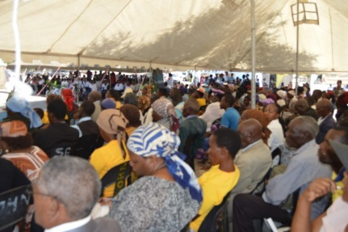

Kgosi Setlhodi Community attendance

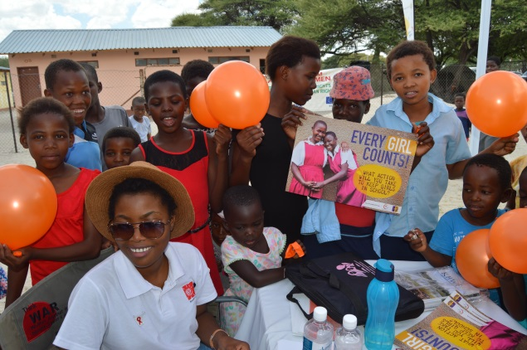 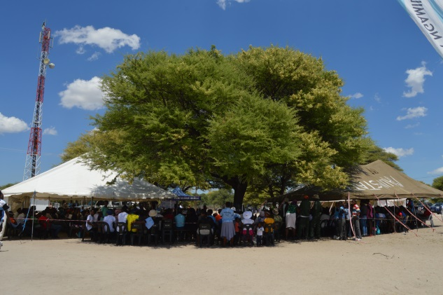

WAR Staff

**Total number reached: 585 Female: 333 Male :252**

**World AIDS Day at Matsaudi village**

The Department of Health Management Team (also known as DHMT) hosted world AIDS day on the 5th December 2017 at Matsaudi (clinic) village with the same theme “Right to Health”. The main purpose of the event was to highlight the community with issues such as: the importance of HIV testing (DHMT), preventing Violence Against Women (WoMen Against Rape), TB testing and treatment (BOCAIP), Alcohol Abuse and many more other social ills.

“Matsaudi is one of the rural areas in Ngamiland Region that is highly affected by HIV and most of the people who are infected are defaulting from the HIV prevention drugs due to alcohol abuse and new infections.”Matsaudi clinic Nurse

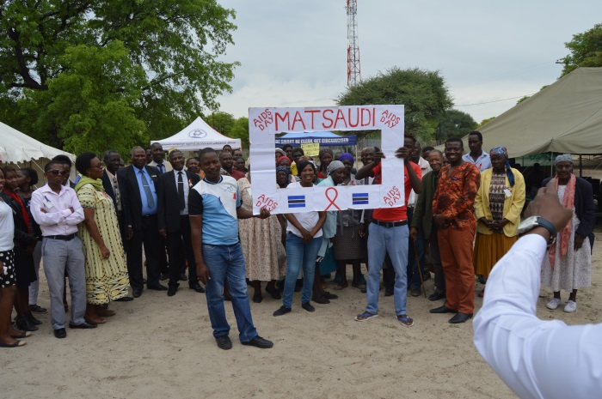 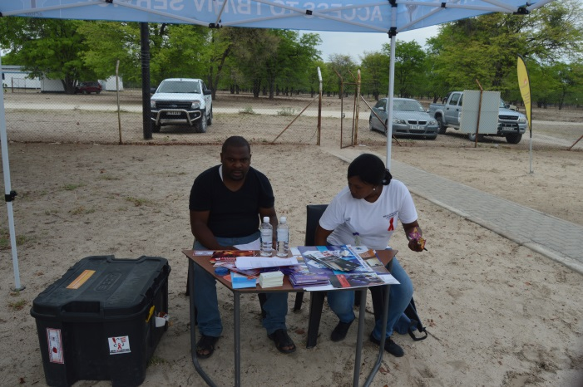

***Total number reached at Matsaudi village: 153 females and 48males=201 total***

SANKOYO VILLAGE WORLD AIDS DAY (16 Days of Activism closing)

Women Against Rape was invited to give a keynote address at Sankoyo on the services that it offers and also to set a stall to inform the Sankoyo community about their services. Sankoyo is a very small village 85km North East of Maun which has a one stop service center that includes a clinic, primary school, police station and a kgotla. Only a few people attended and mostly were the elderly with children under age of 5 years. There were 65 people in attendance made up of women, men and young children.

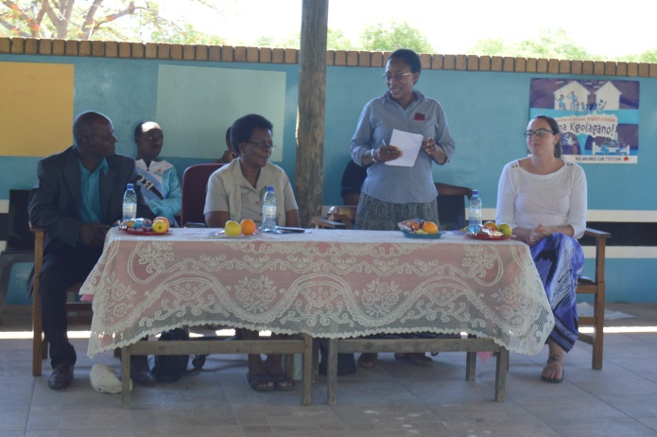 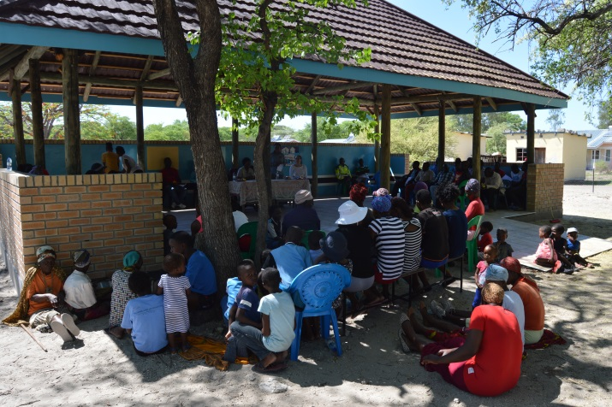

***Total number of people reached: 65 =38 female 27 male***

**GBV FILM SCREENING**

GBV film screening is an initiative that was agreed on by 16 days of activism team to make the community aware about dynamics of gender based violence and also to create a dialogue while watching or at the end of the film. The film was screened at schools and at the bar.

***Schools***

The GBV film “not my body” adopted from Raising voices Uganda was shown in four junior schools namely; Moeti, Tshwaragano, Sedie and Tsodilo. The characters on the film outlined different types of abuse such as incest, rape, defilement and cohered sex.

Most of the comments that came out during the dialogue showed that students understand all types of abuse and those issues portrayed on the film were common in the environment they live in. Students from different schools commit that they will take care of themselves and will not be intimidated by peer pressure or lack of any need.

Total number of people reached through film screening;

|  |  |  |  |
| --- | --- | --- | --- |
| **School** | **Male** | **Female** | **Total** |
| Maun Senior Secondary School | 19 | 113 | 132 |
| Tshwaragono secondary school | 25 | 27 | 52 |
| Moeti junior secondary school | 26 | 20 | 46 |
| Sedie junior secondary  School | 14 | 110 | 150 |
| Tsodilo junior secondary school | 24 | 20 | 44 |
|  |  |  |  |
| **Totals** | **108** | **290** | **424** |
|  |  |  |  |

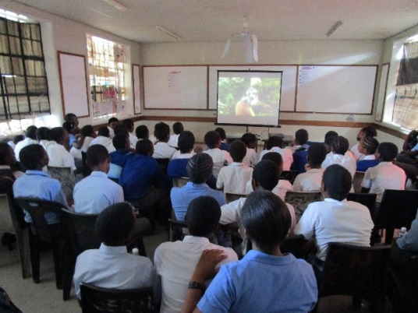 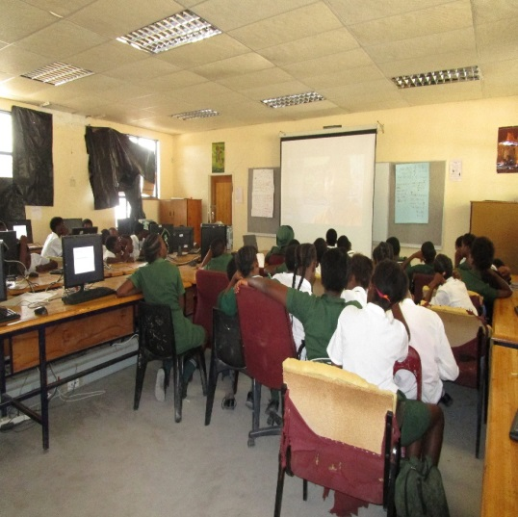

***Bar 24/7***

The Bar was fully packed and a lot of people were interested and had time to watch SHUGA, a mass multi-media behavior change communication initiatives targeting youth. The Shuga video offers intensified and localized HIV prevention education messages along access to vital services including HIV counselling, testing, treatment and care, safe-male circumcision and sexually transmitted infections screening and treatment. No dialogue or videos were taken at the bar as careful consideration was taken looking at the venue and the state the people were in ( drunk) so was not easy to register people. We choose to use bar because that’s where most of the youth go for entertainment during the weekend.

***Total estimated number reached 364 =female 144 male 220***

**TOTAL NUMBER OF PEOPLE REACHED DURING THE 16 DAYS OF ACTIVISM**

|  |  |
| --- | --- |
| **MEDIA INTERVENTIONS** | **TOTAL NUMBER OF PEOPLE REACHED** |
| Facebook | 9687 |
| Events | 1198 |
| Filming | 788 |
| GBV photo frame | 729 |
| **TOTAL** | **12 402** |
|  |

**Successes/Achievements**

* Through all media interventions during 16 days of Activism, we managed to reach 12,402 people.
* We manage to launch and also have a closing event as planned.
* Managed to get informative feedback from community about GBV.
* We introduced 16 days of Activism to people who we not aware of its existence.
* We used all the events to reach out to people using different means/platform.

**Limitations**

* Short notice to stakeholders and also sponsors.
* No sponsor/budget for the 16 days

**Recommendations**

* 16 days team should request for sponsorship well on advance.
* Facilitate the 16days to stakeholders and let them do the events at their organizations.
* Include more media intervention to reach out to people of all ages and different backgrounds and geographies.
* Do enough follow ups
* Only that have confirmed to attend events will be included in the agenda.

.

**Acknowledgement**

Women Against Rape 16 DAYS TEAM would like to offer their gratitude to the following for the support and donations they gave to help in preparation and the successes of the 16 days of Activism Campaign: Motsana, Maun Lodge, BlackReign photography, WAR Stuff, Sedie Junior, Maun Senior, Tshwaragano junior, Moeti junior, Tsodilo junior, Okavango International and Maun Delta Waters, MR Veg and Aquarite Botswana.